NOTE: Please see “Themes Documentation.html” for theme reference for developments/solutions/tips.

Website Url: http://10.10.1.12/samplewebsite/

Admin Dashboard: http:// 10.10.1.12/samplewebsite/**administrator**

CLIENT MAIN ADMIN (username/password): webadmin / 7works

FRAMEWORK ADMIN (username/password): admin / test

1. Copy the files in the latest (Ex. V.10.20.2014) Plug & Play Installer here: \\VIIWORKS-Kirby\Files\Plug and Play\Latest Versions 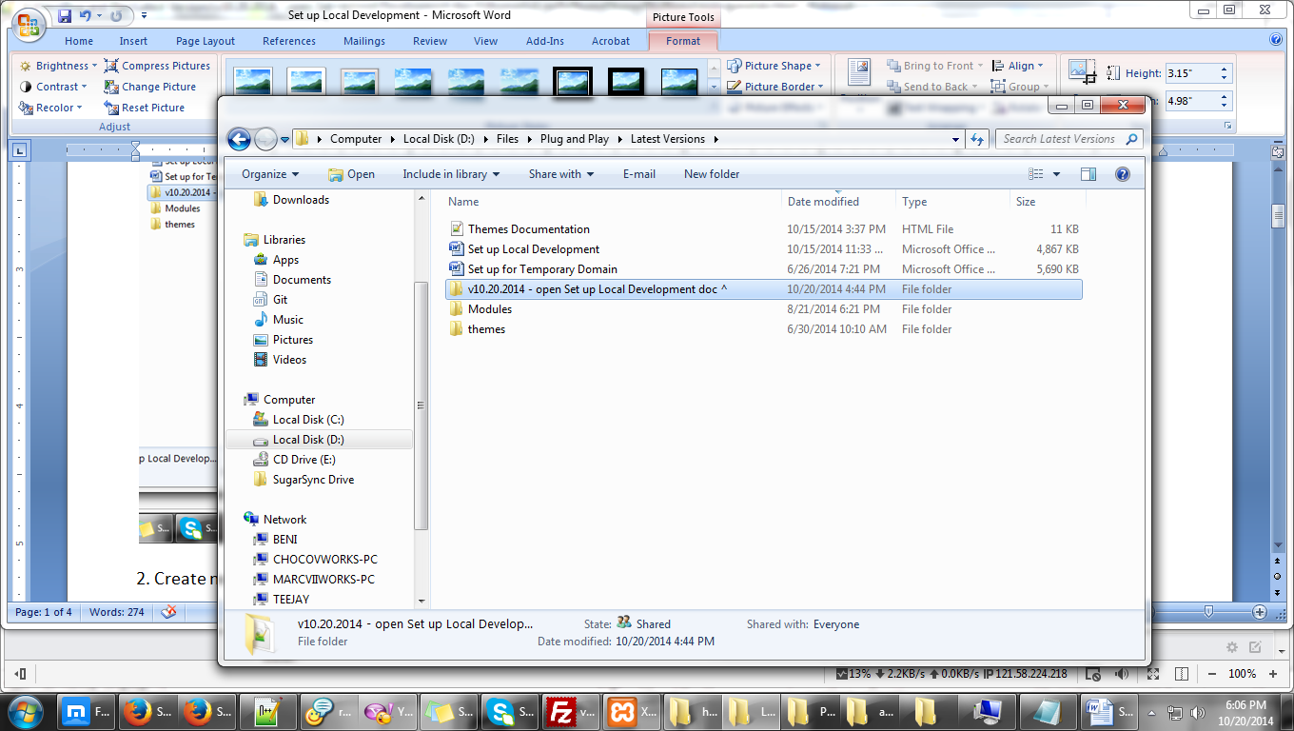

2. Create new project in your xampp htdocs, rename it with **PROJECT NAME** (Ex. samplewebsite), Take note: no spaces, no special characters, the project name should be the same in your database 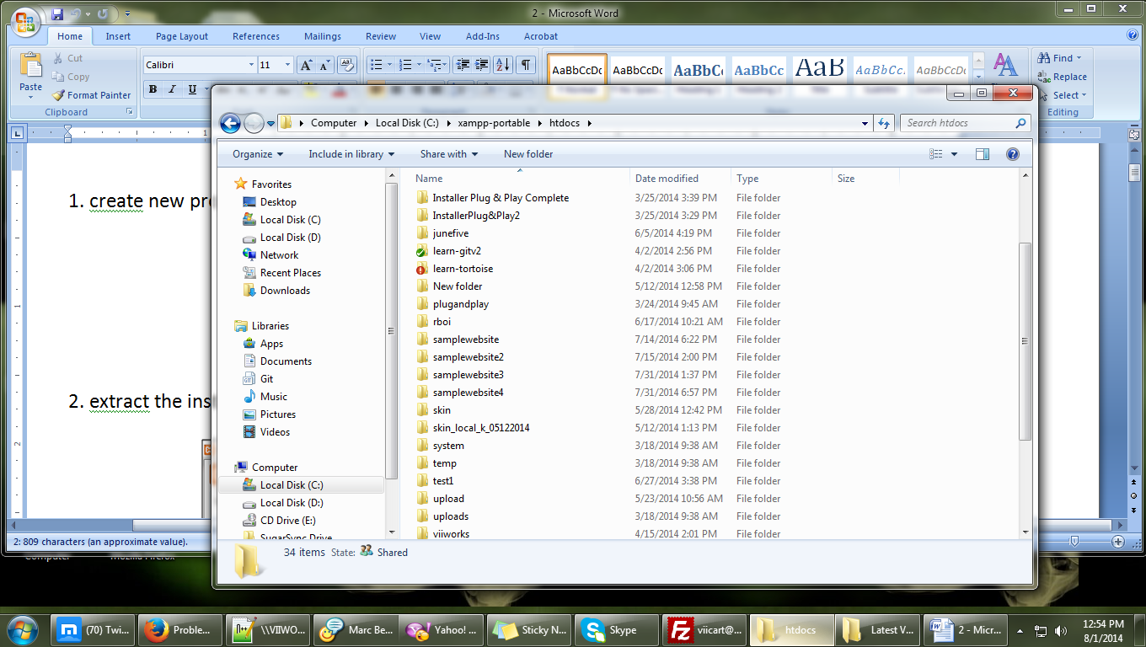 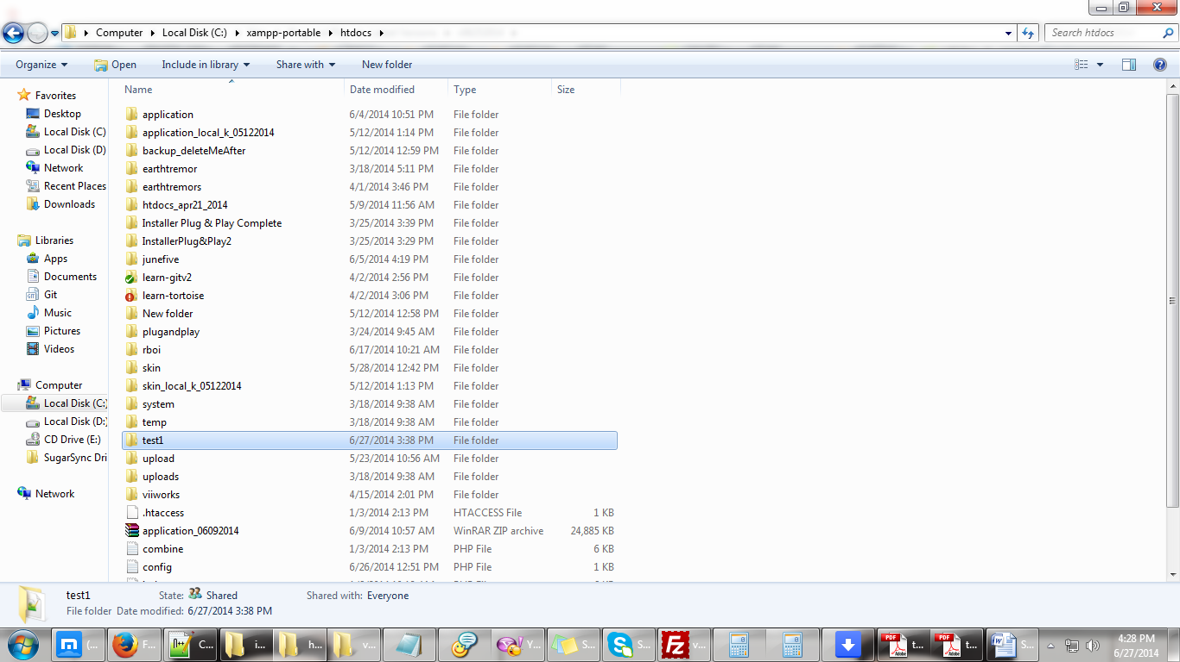

3. Paste the installer inside the project folder 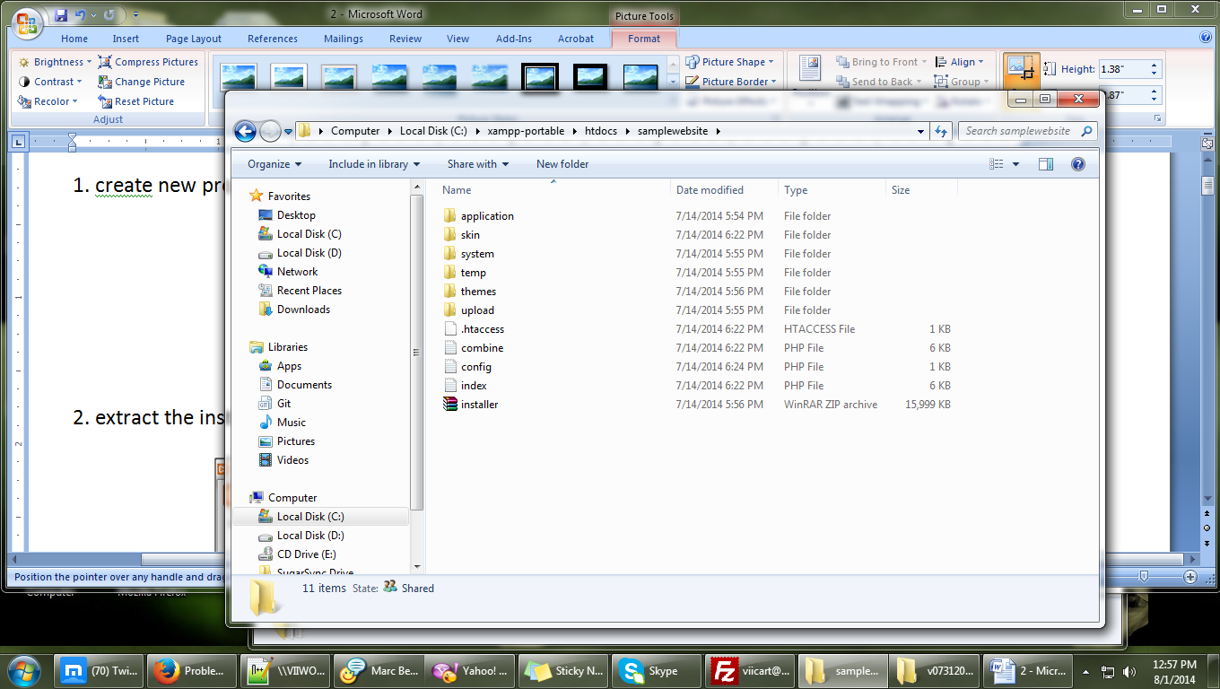

3.1 Your project folder should have the following files and folders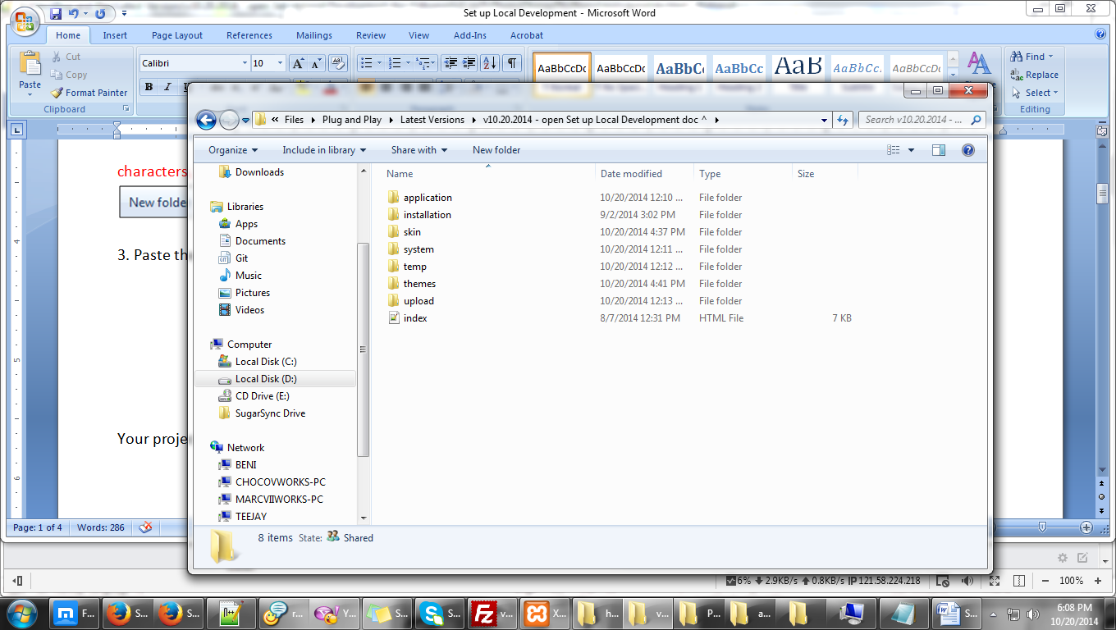

4. Go to themes and rename the folder. **ALWAYS** keep the “**vii_**” **before** the theme name Ex. vii_themename 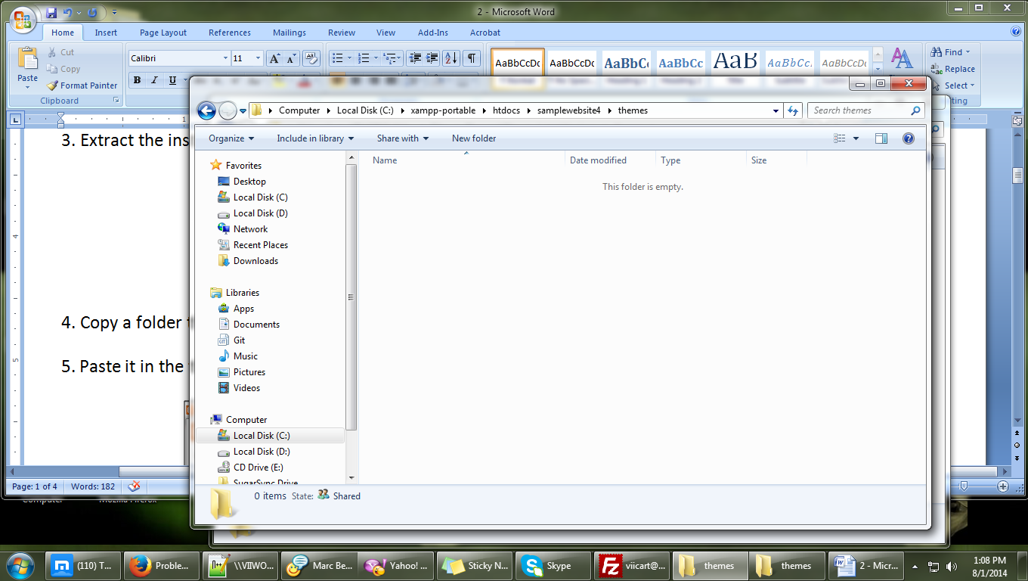 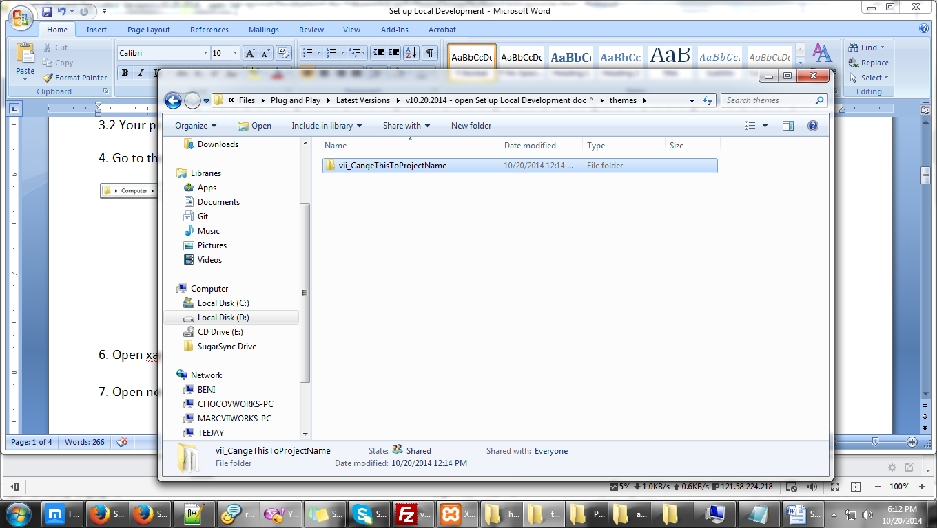

5. Open xampp 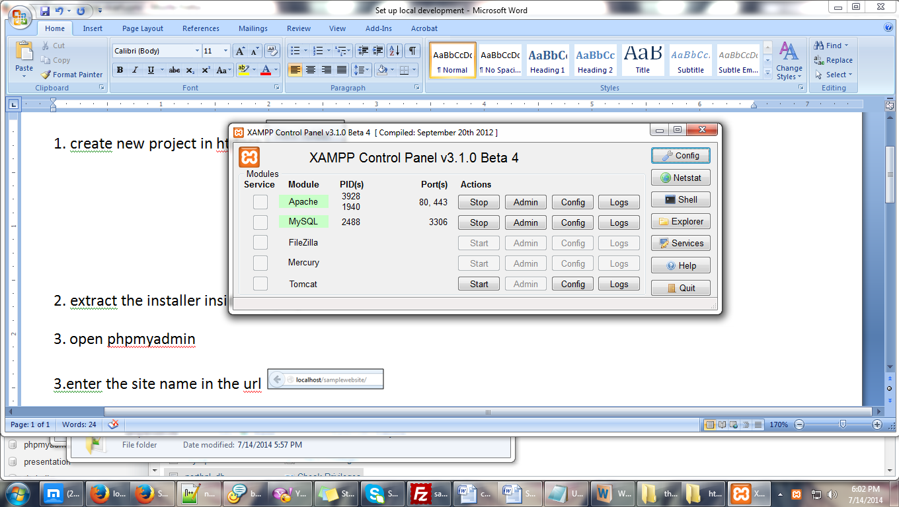

6. Open new tab **enter** in url: localhost/phpmyadmin 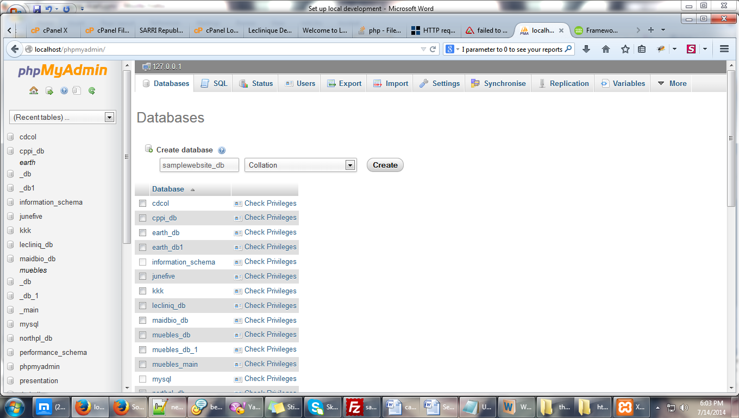

6.1. Click **database** tab 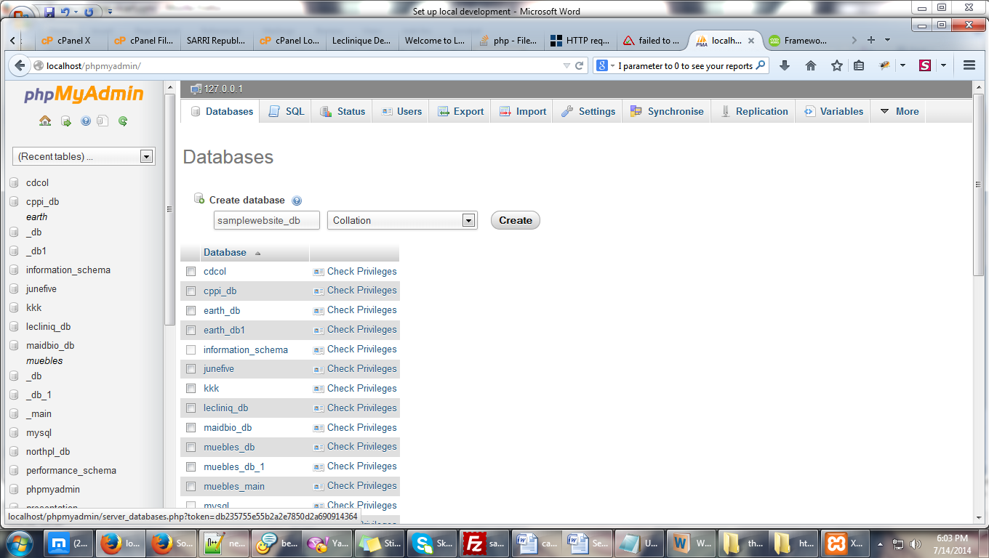

6.2. Enter **PROJECT** name, always put ‘_db’ at the end Ex. samplewebsite_db, this should be **THE SAME** name with the folder you created at #5 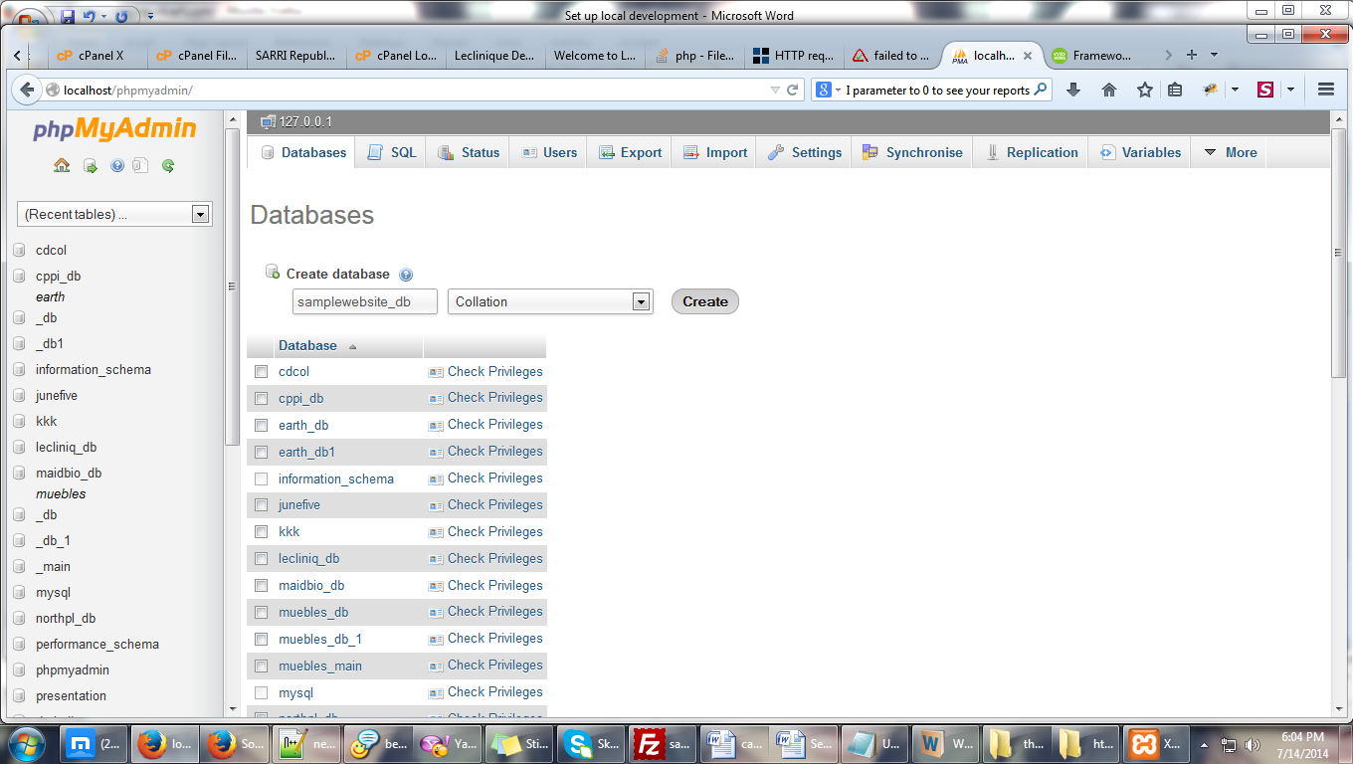

7. Enter the site name in the url, always use your **LOCAL IP ADDRESS** 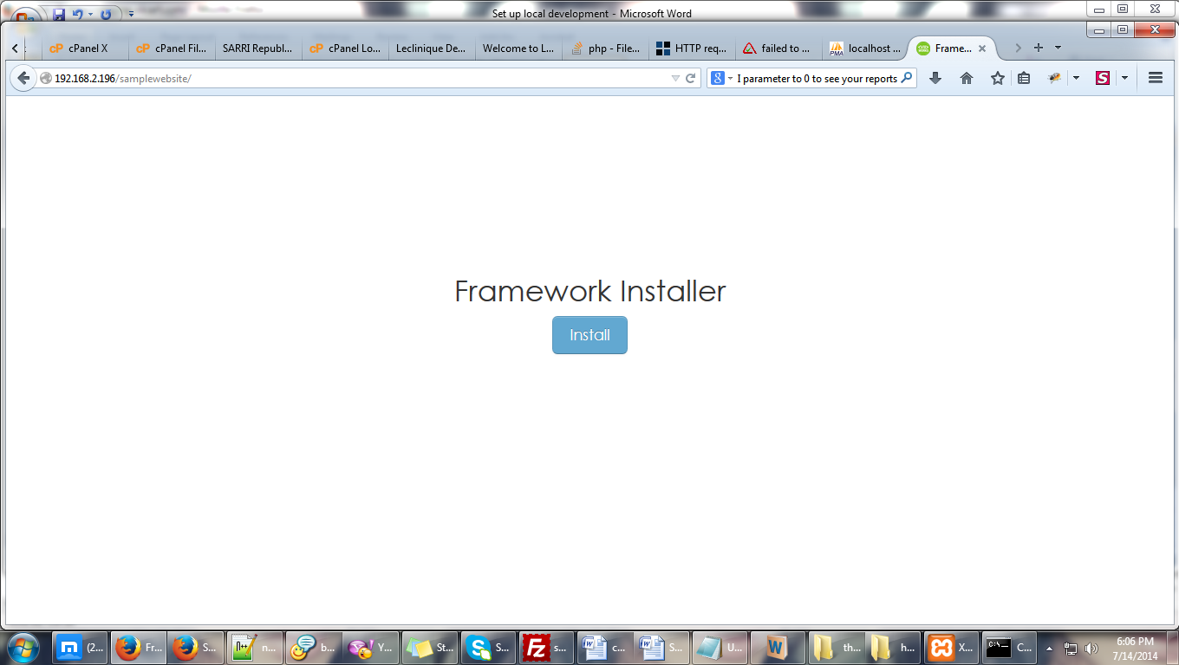

8. Click install 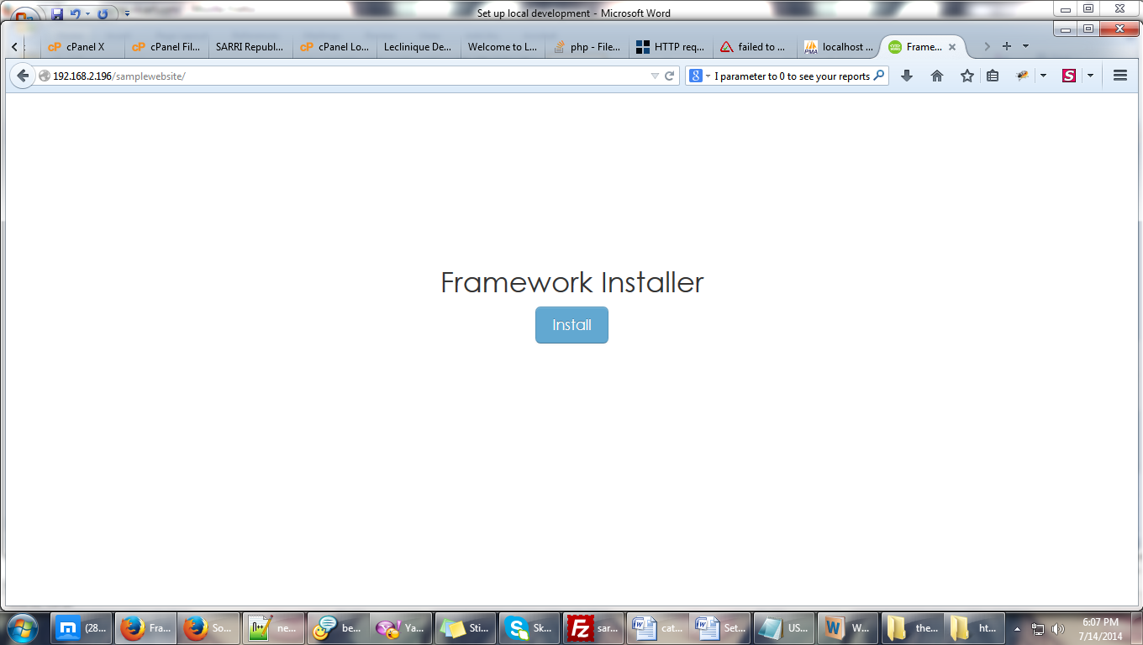

9. Enter the following 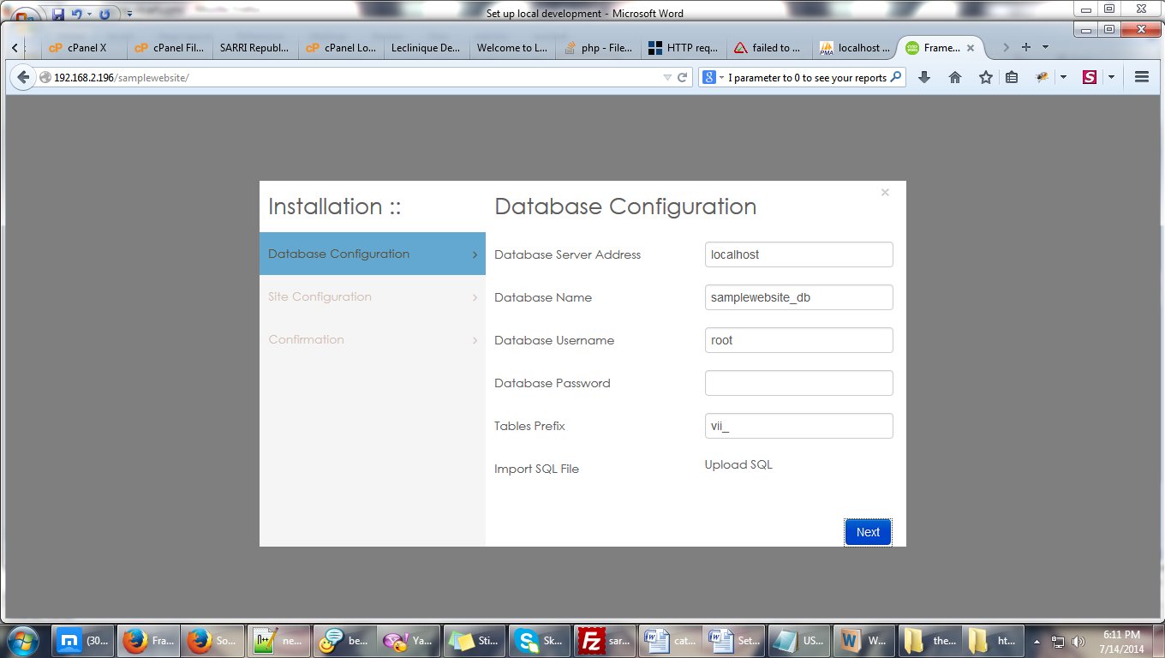

9.1 Database Server Address : localhost - use this

9.2 Database Name: samplewebsite_db - this is **example**

9.3 Database Username: root - use this

9.4 Database Password: leave this **empty**

9.5 Tables Prefix: vii_ - use this

9.6 Click next

10. Enter the following 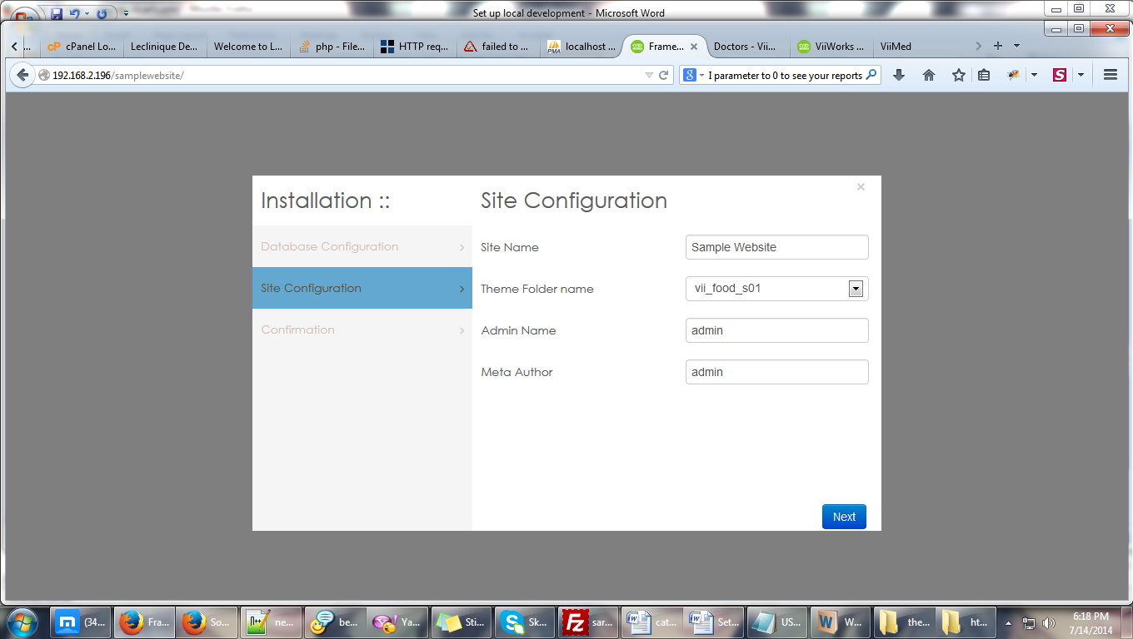

10.1. Site Name: Sample Website - **NAME OF THE WEBSITE**

10.2. Theme Folder Name: vii_food_s01 - **use**

10.3. Admin Name : admin - use this

10.4. Meta Author: admin - use this

10.5. Click next

11. Click next 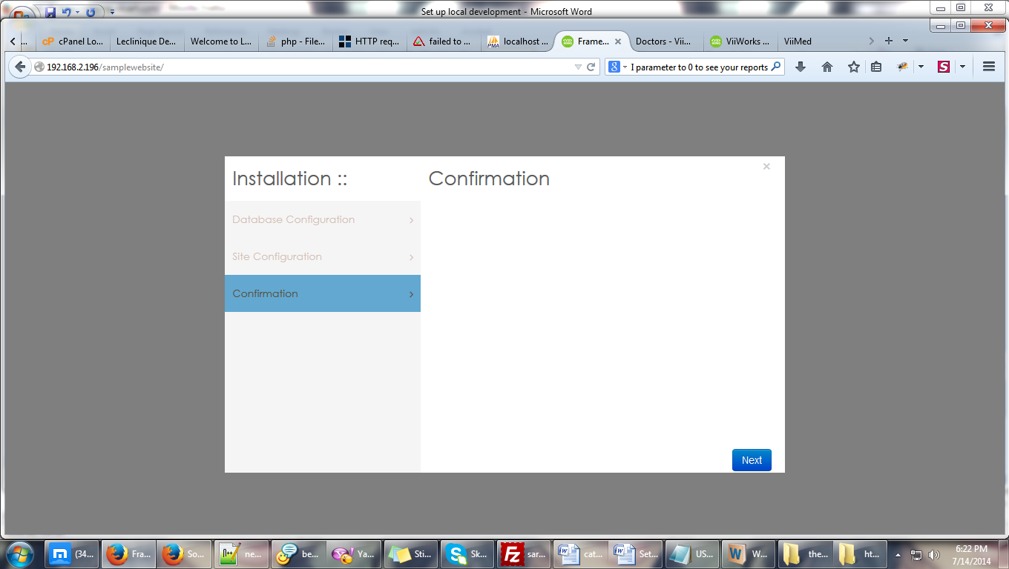

12. Delete ‘themes’ folder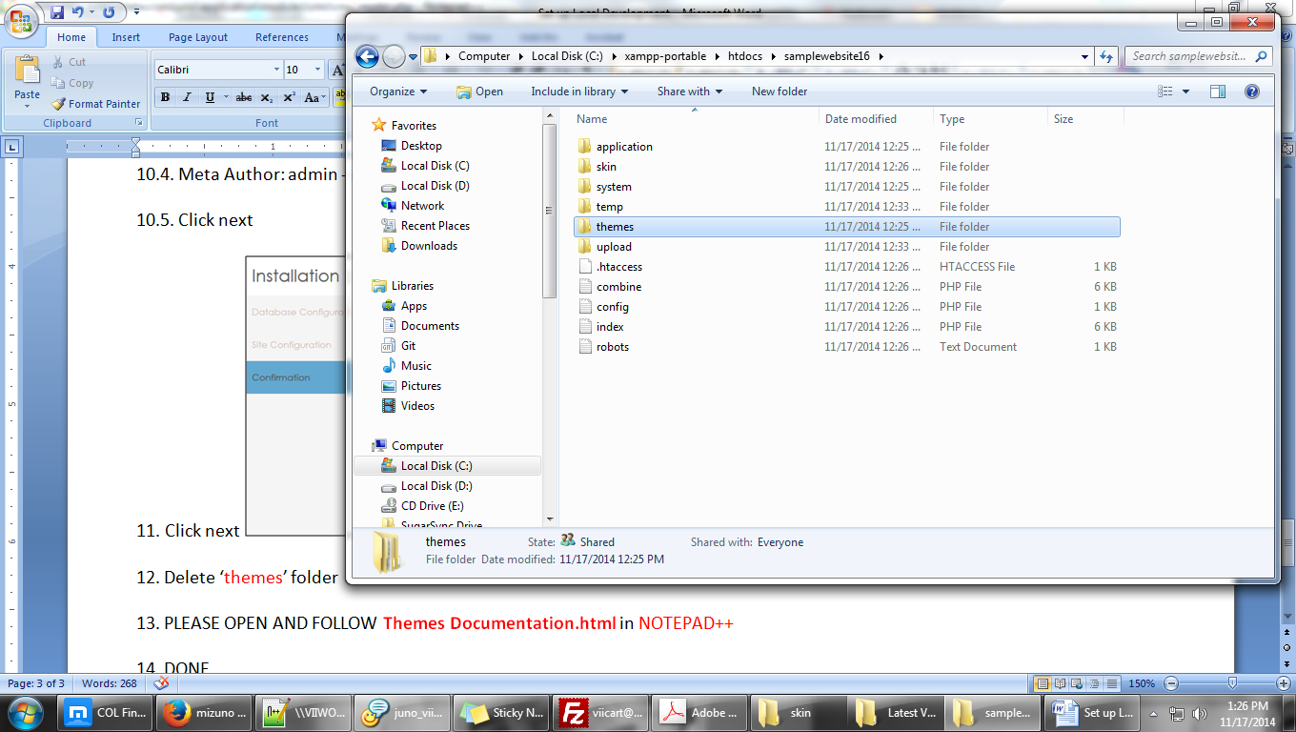

13. PLEASE OPEN AND FOLLOW **Themes Documentation.html** in NOTEPAD++

14. DONE – do hard refresh (press ctrl + f5) if the homepage does not appear